Operating System (CS301)

Practical Exam

**U19CS012**

Q1.) A system has four processes and five resources that can be allocated. The current allocation and maximum needs are as follows:

|  |  |  |  |
| --- | --- | --- | --- |
| Process Id | Allocated | Maximum | Available |
| A | 1   0   2   1   1 | 1   1   2   1   3 | 0   0   2   1   2 |
| B | 2   0   1   1   0 | 2   2   2   1   0 |  |
| C | 1   1   0   1   0 | 2   1   3   1   0 |  |
| D | 1   1   1   1   0 | 1   1   2   2   1 |  |

**Bankers Algorithm**

* Banker’s Algorithm is a **deadlock avoidance** algorithm.
* It is also used for **deadlock detection**.
* This algorithm tells that if any system can go into a deadlock or not by analyzing the currently allocated resources and the resources required by it in the future.

**Code**

*#include* <stdio.h>

*#include* <stdlib.h>

*#include* <stdbool.h>

int need[100][100], allot[100][100], max[100][100], available[100];

bool isFinished[100];

int sequence[100];

void isSafe(int N, int M)

{

    int i, j, work[100], count = 0;

*// Intialize the Available Resoures*

*for* (i = 0; i < M; i++)

        work[i] = available[i];

*// Mark all the Process as Unfinished*

*for* (i = 0; i < 100; i++)

        isFinished[i] = false;

*// Until all the Processes are Processed, Run the Algorithm*

*while* (count < N)

    {

*// Let's Assume Intially that Allocation is Not Possible*

        bool canAllot = false;

*// Check if Any Process can be Allocated*

*for* (i = 0; i < N; i++)

        {

*// Is the Process Left?*

*if* (isFinished[i] == false)

            {

*for* (j = 0; j < M; j++)

                {

*if* (work[j] < need[i][j])

                    {

*break*;

                    }

                }

*// Remaining Needs <= Current Availibility*

*// Therefore, Allocate this Process in Safe Sequence*

*if* (j == M)

                {

*for* (j = 0; j < M; j++)

                    {

                        work[j] += allot[i][j];

                    }

                    sequence[count++] = i;

*// Mark the Process as Completed*

                    isFinished[i] = true;

*// Allocation was Possible*

                    canAllot = true;

                }

            }

        }

*// If No Such Process was Available for Current Available Resource*

*// Then, Deadlock Will Occur and System is Not in Safe State*

*if* (canAllot == false)

        {

            printf("System Is Not Safe\n");

*return*;

        }

    }

*// If Control, Reaches Here, All Process have been able to Allocate and Safe Sequence Exist*

    printf("System is in Safe State\n");

    printf("Safe Sequence :");

*for* (i = 0; i < N; i++)

    {

*if* (i == N - 1)

            printf("%d", sequence[i]);

*else*

            printf("%d -> ", sequence[i]);

    }

    printf("\n");

}

int main()

{

    int i, j, N, M;

    printf("Enter the Number of Process and Resources :");

    scanf("%d %d", &N, &M);

    printf("Enter the Available resources [Intially] :\n");

*for* (i = 0; i < M; i++)

        scanf("%d", &available[i]);

    printf("Enter the Allocation Matrix :\n");

*for* (i = 0; i < N; i++)

*for* (j = 0; j < M; j++)

            scanf("%d", &allot[i][j]);

    printf("Enter the Matrix for Maximum Demand of Each Process :\n");

*for* (i = 0; i < N; i++)

*for* (j = 0; j < M; j++)

            scanf("%d", &max[i][j]);

*// Calculation of need matrix [Remaining Need]*

*for* (i = 0; i < N; i++)

*for* (j = 0; j < M; j++)

            need[i][j] = max[i][j] - allot[i][j];

    isSafe(N, M);

}

**Output**

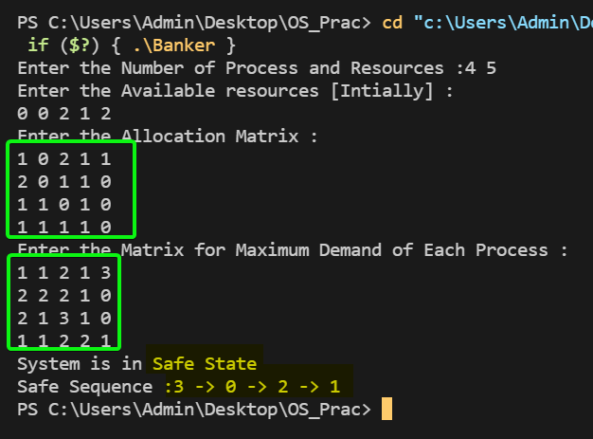

Thus, we have Successfully Understood and **Implemented** Bankers Algorithm.

SUBMITTED BY:

**U19CS012**

BHAGYA VINOD RANA